General Risk Assessment Form: Community Engagement
Organisation: |  | Booking Ref:
Contact Name:
Name of Assessor: |  | Date:
Activity:
General information:

Activity | Hazards | Control Measures | Severity (S)  1 - 5 | Frequency (F)  1 - 5 | Risk Rating  S x F

Risk Assessment Rating | Unacceptable Risk 15 - 25 | Moderate-High Risk 8 – 12 | Low-Moderate Risk 4 – 8 | Low Risk 1 - 3

Declaration
Providing the control measures specified are complied with, I consider the risks identified are acceptable.
Assessors Signature: |  | Date:
Reviewed by CE Team: |  | Date:

Risk Matrix
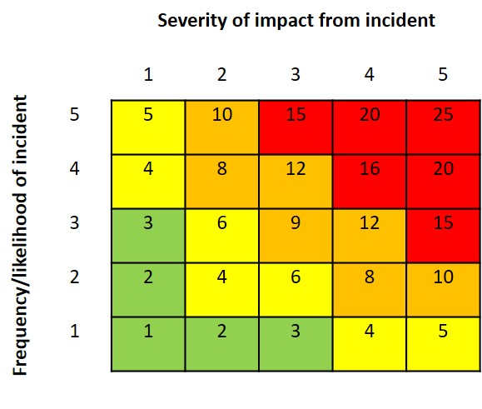
Severity of impact from incident
1 | Little to no negative impact on College | Very low
2 | Minor disruption or negative impact to College | Low
3 | Some noticeable disruption/impact but manageable | Medium
4 | Major disruption or negative impact to College | High
5 | Becomes a crisis and Emergency Planning is needed | Very high
Frequency/likelihood of incident
1 | Very unlikely incident will happen | Very low
2 | Small likelihood event could happen, less than 25% chance | Low
3 | Could happen, with at least a 50% likelihood | Medium
4 | Reasonable likelihood of incident happening, up to 75% chance | High
5 | Confident that incident is likely to happen | Certain
Score Rating (rating of Severity x Frequency)
1 – 3 | Low Risk | Review on change of process or if circumstances change. No great effort required to reduce risk further.
4 – 6 | Low-Moderate Risk | Investigate engineering controls to minimise reliance on PPE & procedures. Provide additional training, supervision & monitoring of agreed controls until accepted as routine.
8 – 12 | Moderate-High Risk | Critically examine the areas of exposure in the process, and agree a timetable for completion of all agreed actions. Review on implementation, and closely monitor effectiveness of new controls.
There is a threshold risk level of 15, at or above which immediate action must be taken
15 – 25 | Unacceptable Risk | Cease work until effective interim controls are agreed and implemented, and an action plan to permanently reduce the risk to an acceptable level has been agreed with the Executive Group. This condition is mandatory.

